MENTAL HEALTH RESOURCES

Phone and web resources:
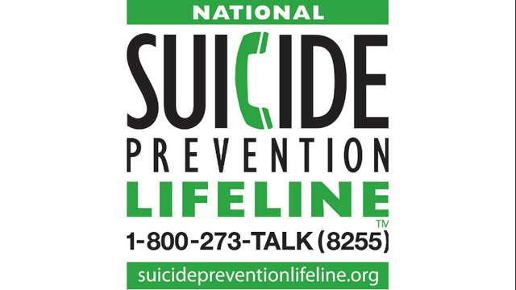

The National Suicide Prevention Lifeline 800-273-8255
A 24/7, free and confidential support for people in distress, prevention and crisis resources

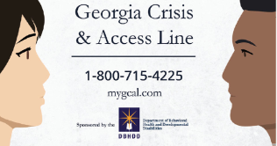 Access to Crisis Services
For immediate access to routine or crisis services, please call the Georgia Crisis and Access Line (GCAL) at 1-800-715-4225 or download MYGCAL App is available 24 hours a day, 7 days a week and 365 days a year to help you or someone you care for in a crisis. GCAL professionals will
- Provide telephonic crisis intervention services
- Dispatch mobile crisis teams
- Assist individuals in finding an open crisis or detox bed across the State
- Link individuals with urgent appointment services
Crisis Text Line Text HOME to 741741
A free, 24/7 text line for people in crisis

National Hopeline Network 800-784-2433
A helpline and online chat resource

The Trevor Project 866-488-7386
A phone number, online chat and text resource for LGBTQ people between the ages of 13-24

MENTAL HEALTH VIDEOS, APPS, AND TIPS
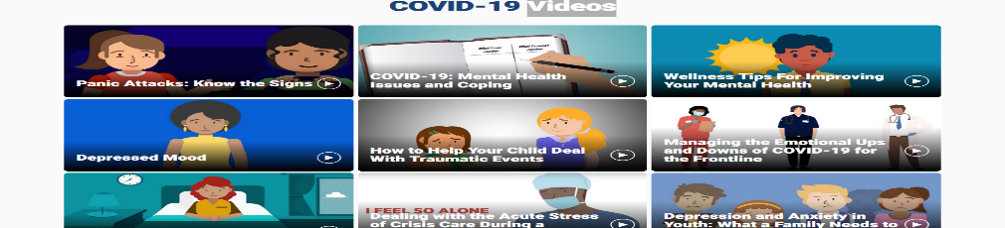
https://psychhub.com/covid-19/covid-individuals/covid-individuals-videos/

Calm-Breathe, Meditate Relax, and Sleep App Tips
